Getting Started With

# HOLO

A DTrack module for   
Inline-Holography-Tracking



Getting Started With

# HOLO

HOLO is a DTrack-module specifically developed for tracking the movement of small lifeforms in Inline-Holography videos. Building on the manual tracking architecture of DTrack, it offers a series of new modes to support the different layers of holographic videos, and three-dimensional auto-tracking capabilities.

## Installation

Holo is currently hosted in the dev_holo branch of the dtrack repository at <https://bitbucket.org/jochensmolka/dtrack> . If you are comfortable using git, check out this branch of the repository, and you will always have access to the latest development versions of HOLO.

Otherwise, you can download the current version as a zip-file from <https://bitbucket.org/jochensmolka/dtrack/get/dev_holo.zip> and extract it into your Matlab directory. Always make sure to delete old versions, as they have a tendency to linger on the Matlab search path and provide you with outdated zombie functions!

## Starting HOLO

After opening Matlab, change into the directory that holds your HOLO installation, type holo and press Enter. The HOLO start-up dialog will appear.

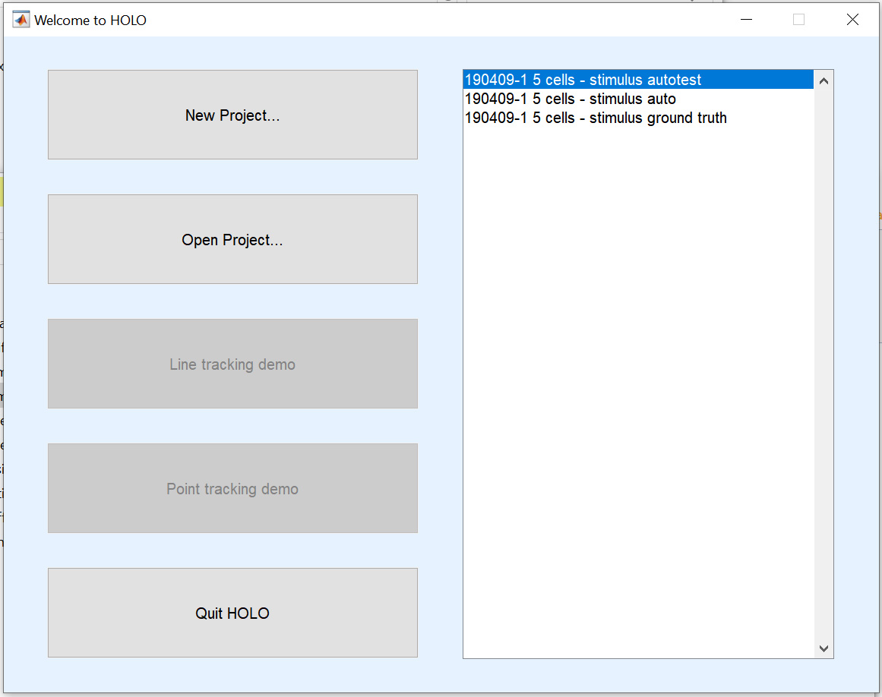

If you have already saved a previous project, it should come up in the list of recent saves on the right; or, you can click “Open project…” to find it on your hard drive. Otherwise, select “New Project…”, and a dialog will open asking you to select the video file for the new project.

The “HOLO parameters” dialog will open up.

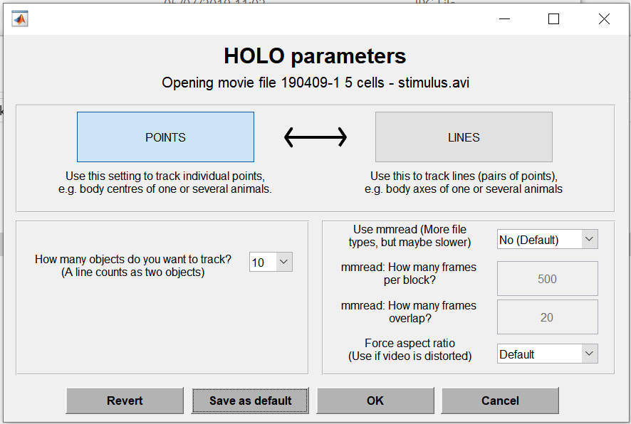

Make the following choices here:

* Whether to track points or lines. Your default choice here will be points, unless you want to specifically track things like the body or head orientation of animals or interactions between animals. (Note that you can always track a line as two points, and post-process afterwards).
* How many objects to track. If you are unsure, select the maximum (10), because *it is currently not possible to add additional objects to an existing save file*.
* If you have a weird video format that Matlab cannot natively read on your operating system, you can read it using *mmread*. This method reads frames from the video in a slightly different way, so you will have to select a block size (the number of frames that is loaded into the buffer at any one time; reading from this buffer is fast, but you will experience some load time when you move past the buffer boundaries).

Once you are done here, press “OK” and start tracking!

## First steps

First, it might be useful to make yourself familiar with the keyboard shortcuts, which you can find in the *Help* menu.

These are a few of the more common things to do:

* Change frames with the left and right arrow button (by default, this is ± 10 frames; use up and down arrow to go one frame at a time, and SHIFT + left/right to go 50 frames)
* Change object with the number keys (1 to 0)
* Zoom in/out with the mouse wheel
* Pan by clicking the right mouse button in the desired centre location
* Manually track a point by clicking the left mouse button on its location

The right mouse button is also a useful tool when the main window loses focus (which seems to happen particularly frequently on Mac). By pressing the right mouse button near the centre of the window, you return focus to the window while only minimally changing your view.

## HOLO view modes

At the top of the HOLO settings window on the right side of your screen, you will find the four HOLO view modes.

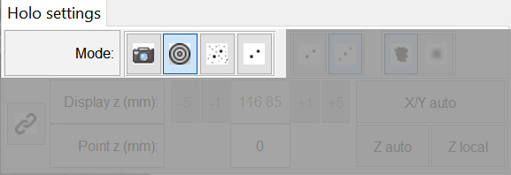

**Camera mode**: In this mode, the raw camera image is shown. This is not very useful for tracking, but can sometimes be handy to see changes in lighting during the recording, and to determine the position and outline of the experimental area.



C:\Users\Jochen\AppData\Local\Microsoft\Windows\INetCache\Content.Word\interf.tif **Interference mode**: This mode shows the interference pattern visible when frames are subtracted from one another. This is useful to find the rough position of moving objects. The displayed image depends on the value of “ref diff” in the top right corner, which determines the distance between frames that are subtracted to create the difference image.

**Hologram mode**: In this mode, the reconstructed hologram of the whole frame is shown. The calculations depends on “ref diff” and the “Display z” setting.



**Enhanced hologram mode**: Use this mode to get the best view of your tracked object. For the area around the currently selected/tracked object, a zoomed in hologram is calculated, which has dramatically less background noise, and better contrast. Note that this mode is only available if the current object has been tracked at least once; if it has not been tracked in this frame, the program will automatically find the nearest tracked point, and centre the enhanced area on that location.



Which mode you choose will affect how fast you can navigate through frames: The more processing needs to be done, the longer it will take.

## HOLO reference modes

To the right of the View modes, you can choose between single and double reference mode.

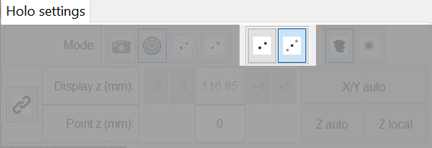

**Single reference mode** subtracts a previous frame from the current frame. In the resulting difference image (and consequently the holographic images), you will see two equally dark points, which are the object’s previous and current location. As you move through the frames, it is easy to see which is which, but this is impossible from looking at a single frame.



**Double reference mode** subtracts a previous *and* a future frame from the current frame. In the resulting difference image (and consequently the holographic images), you will see three dark points, which are the object’s previous, current and future location. The previous and future location points are much fainter, so it is usually easy to see which is the current location, even from looking at a single frame. On the downside, loading an extra reference frame requires extra processing time, so moving from one frame to the next is slower in this mode.



## HOLO Z modes

At the end of the line of modes, you can select between single and mean Z-mode.

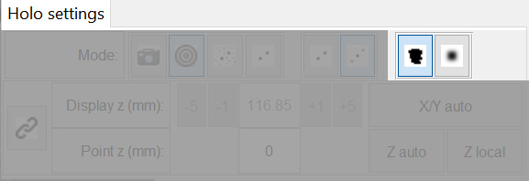

**Single Z mode**: In this mode, the holographic representation is calculated for a single z-plane (depending on “Display z”). This is fast, but if the z-value is chosen wrong, you will not be able to see your object.



**Mean Z mode**: In this mode, the hologram is calculated for the full range of possible z-positions, and the mean is displayed. In this view, you will almost always be able to see the tracked object, and you do not need to set a z-value. On the downside, navigation is a lot slower due to the increased processing demand.



## Z navigation

The next part of the HOLO settings window deals with Z-positioning.

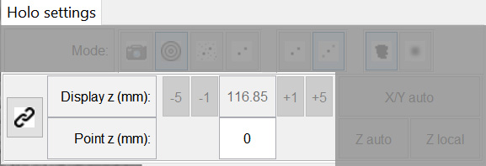

In the top row, you can enter and adjust the currently displayed Z-plane. Remember that this will affect your view in “Interference mode”, as well as in “Hologram mode”/”Enhanced hologram mode” if you have “Single Z mode” activated.

In the bottom row, the tracked Z-value for the current object is shown (or 0, if it has not been tracked). You cannot enter this value manually, but need to auto-detect it (see next section). By pressing the link button at the left side of the panel (), you can link the displayed position to the object’s z-position: Whenever you change the selected object or frame, the displayed z-position will shift to that of the selected object, if it has been tracked.



## Semi-automatic tracking

The last section of the HOLO settings panel offers semi-automatic tracking options, which will automatically find the position of the currently selected object in this frame.

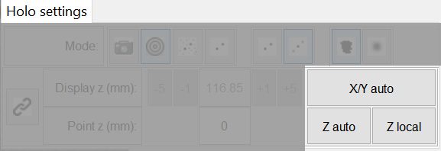

**X/Y auto**: Automatically find the currently selected object in this frame using default tracking parameters. If only one object is currently being tracked, the program will then move on to the next frame. Note that this will only work if the object has been tracked in the past reference frame: For example, if you are on frame 100, and “ref diff” is 5, then semi-automatic tracking will only be available if the object has been tracked in frame 95.

**Z auto**: Calculates holographic images for the full range of Z values and finds the best focus to an accuracy of 50 m for the area around the currently selected and tracked point.

**Z local**: Calculates holographic images only for Z values within ± 2mm of the current “Display z”. Faster than Z auto, and can help when objects are crossing paths.

## Fully automatic tracking

Using the HOLO menu, you can fully automatically track X/Y and Z-positions.

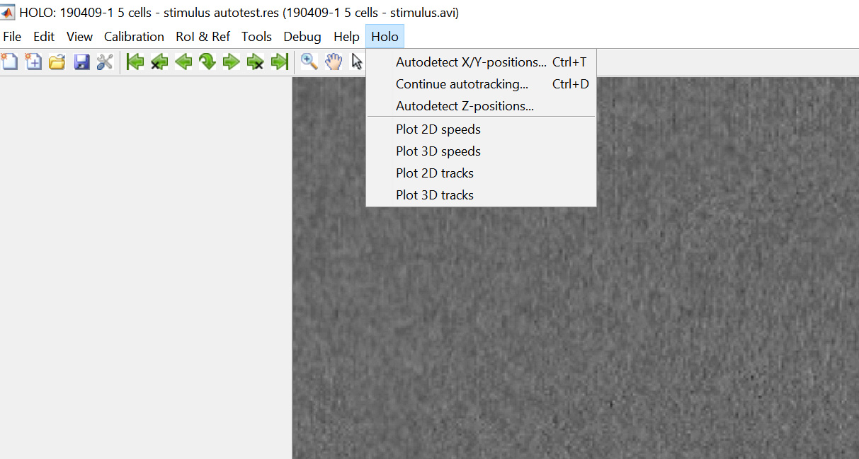

**Autodetect X-Y positions (CTRL+T)**: A parameter dialog will open up where you can select the range of frames you would like to track, as well as some tracking parameters. By clicking “Preview” you can see a preview of what tracking would look like at the “From frame” given the currently selected parameters. The autotracking algorithm needs a nearby x-position to start from. A frame can thus only be autotracked if the object has been previously tracked within ± 100 frames. See below for a suggested workflow for autotracking. You can cancel the auto-tracking at any time by pressing the “Cancel” button on the progress bar window; the progress up to that point will be saved.

Note that the speed of autotracking depends largely on how much information you want to display during the tracking process. If you disable “Show tracking” and “Show diagnostics”, it will be the fastest. Enabling “Show tracking” is only recommended for short test sequences.

**Continue autotracking (CTRL+D)**: This is a shortcut to continue autotracking after an interruption. The parameters dialog will be skipped – using the same parameters as during the previous run – and tracking will start from the current frame and continue until the end of the video.

**Autodetect Z positions**: This function autodetects the Z-position for the current object for all frames starting from the current frame, at a step rate according to “step size”, until the end of the video. If the current object is not tracked in a particular frame, that frame will be skipped. Note that the results are only saved after the function is finished. If you somehow interrupt the tracking or an error occurs, the Z-positions will not be saved.

*Note: A parameter dialog and intermediate saving will be added to the Auto-Z function in a future update.*

## Suggested auto-tracking workflow

After starting a new project, follow this easy workflow to autotrack your objects:

1. In “Interference mode”, navigate through the frames until you find a clear interference circle. Click in the middle of that circle to mark the position.
2. You will be taken to the next frame automatically. Press “left arrow” to return to your tracked frame, switch to “Enhanced hologram mode” and check that you can see the object as a black dot. You may want to zoom in using the mouse wheel, and pan to the correct point with the right mouse button. (You can drag the tracking circle onto the object if you missed it in your first attempt, but that is not necessary; it will be tracked automatically in the next step).
3. From the HOLO menu, select “Autodetect X/Y positions...”. In the parameters dialog, choose your tracking parameters. Make sure to start tracking “From” the frame you are currently on. Choose how much to display of the tracking process, but be aware that displaying this information slows down the tracking. Start tracking.
4. The tracking will end in one of two ways:
   1. If the object moves out of the trackable area, becomes occluded, or is hard to track for some other reason, the tracking program will automatically skip a few frames and continue. If this is not resolved after 100 frames, the tracking will stop. You can then continue from this frame by returning to step 1 (search in interference mode until you find the point again. Then, mark the point in that frame and restart tracking with CTRL-D.
   2. If the tracking reaches the end of the file, you are finished with this point. Move on to step 5.
5. You can now return (maybe **SAVE** first!) to the first video frame (shortcut: S), and continue in one of two ways:
   1. Perform automatic Z-tracking for the point you just tracked. Make sure you are on the first tracked frame, and that your step size is the same as you used during X/Y-tracking. Then select “Autodetect Z-positions” from the HOLO menu and wait as the autotracking routine makes its way through the video.
   2. Select a new object (either by pressing a radio button in the “Objects” panel, or by simply pressing the corresponding number on your keyboard), and start tracking from Step 1.